**PROJECT DOCUMENTATION**

**DATA STRUCTURES AND ALGORITHMS**



**TOPIC: Airline Management System  
Group Members:  
Usman Obaid (2112338)  
Wajih Rashid (2112332)  
Karan Kumar (2112307)  
Koonj Mahnoor (2112310)**

**Project Statement: This module being proposed will contain our ordinary airline management system; which includes the basics; ticket booking, ticket cancelling and flight timings, total cost of the ticket**

**Interface of the Project: GUI based on IntelliJ.**



**Functionality of the Project:**

* **Read**
* **Create**
* **Update**
* **Delete**



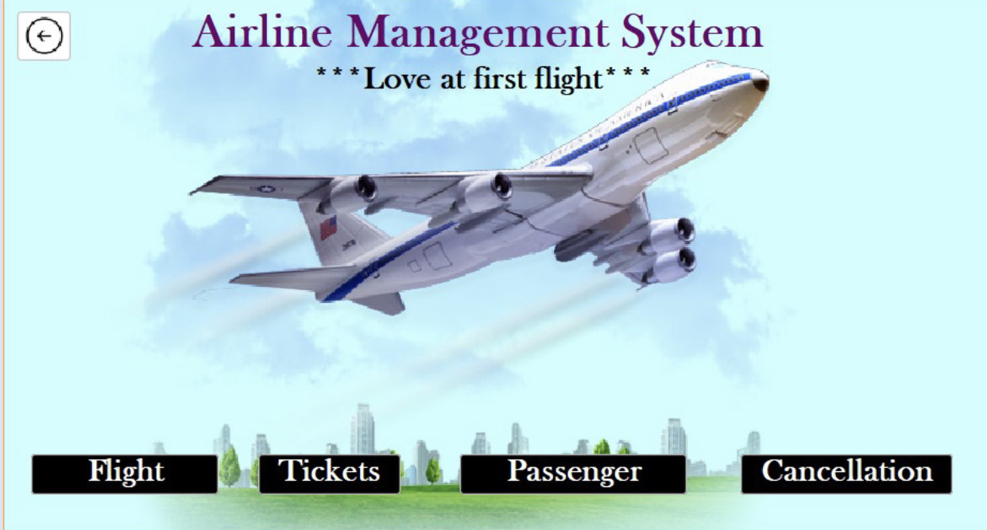

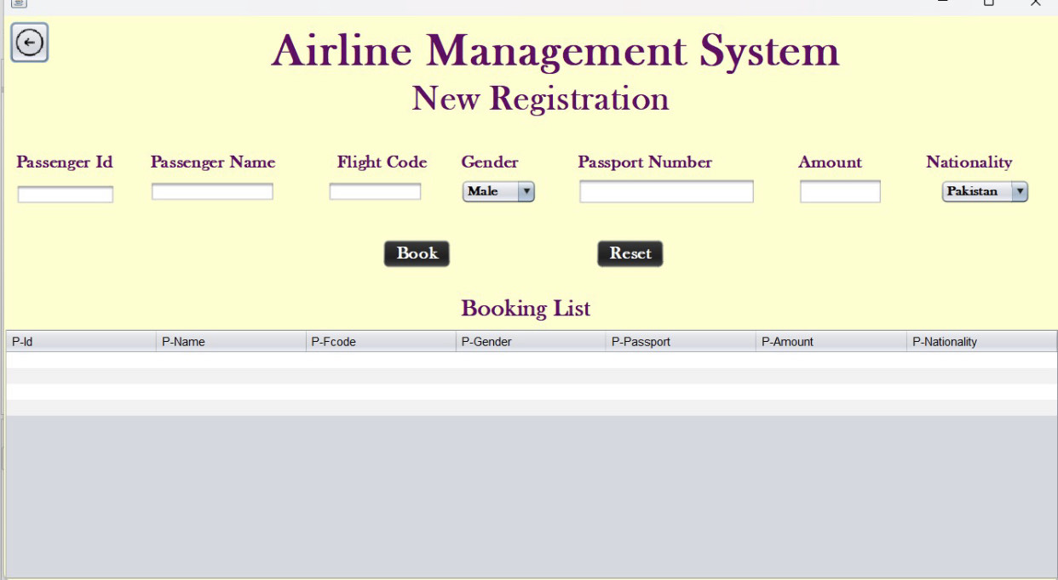

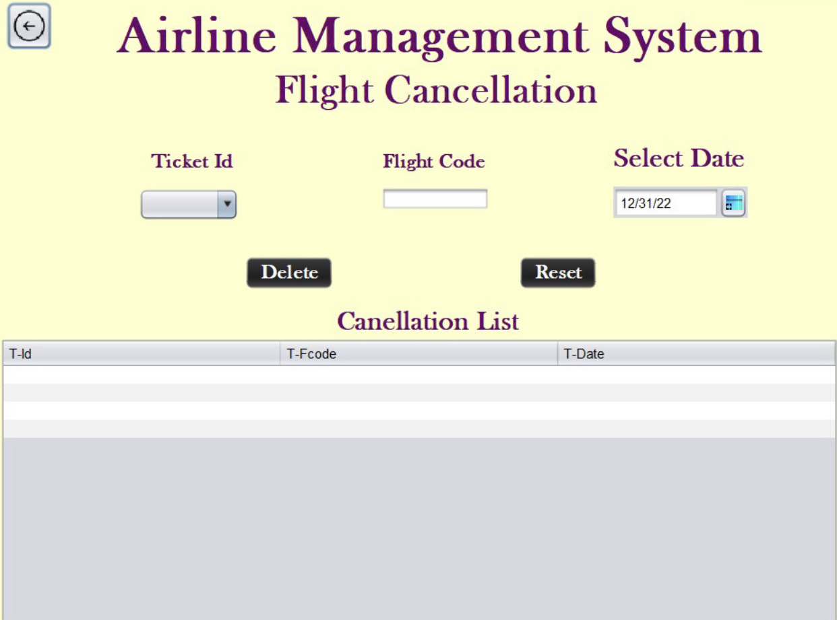

**How DSA is being used in the project:**